Name: __________________________________________ | Class: _______

The Charms of My Life
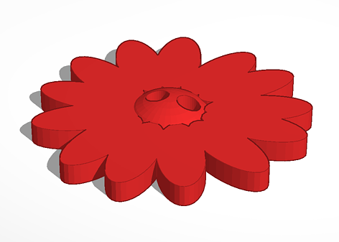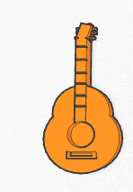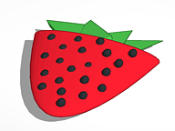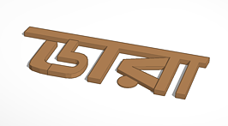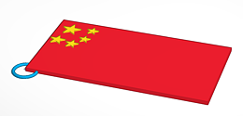
Your job is to use tinkercad.com and our classroom Makerbot 3-D printer to create one or a set of charms about you and your life. After you design and print your beads we can make them into a bracelet, a necklace, a keychain or you can keep them in a special pouch for safekeeping.

Part 1- “I Want You to Know That I…”
Make a list. What are some of the things that you want your teachers and classmates to know about you? What are your hopes and dreams? What are some of your favorite things? What things are you scared of? What do you like to do and eat?

I want you to know that I ______________________________________________________________________________________________.

I want you to know that I ______________________________________________________________________________________________.

I want you to know that I_______________________________________________________________________________________________.

I want you to know that I ______________________________________________________________________________________________.

I want you to know that I ______________________________________________________________________________________________.

I want you to know that I ______________________________________________________________________________________________.

I want you to know that I ______________________________________________________________________________________________.

I want you to know that I_______________________________________________________________________________________________.

I want you to know that I ______________________________________________________________________________________________.

I want you to know that I ______________________________________________________________________________________________.

