Name:

Create Your Own Chess Set

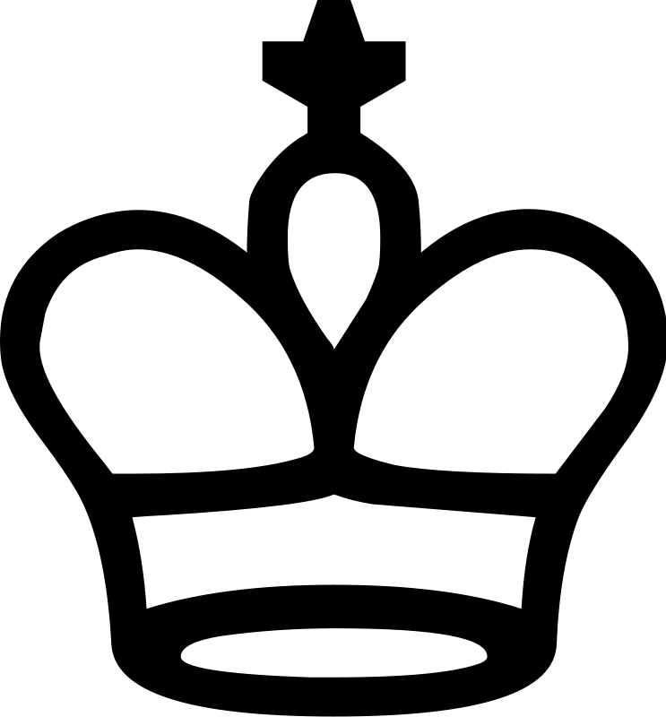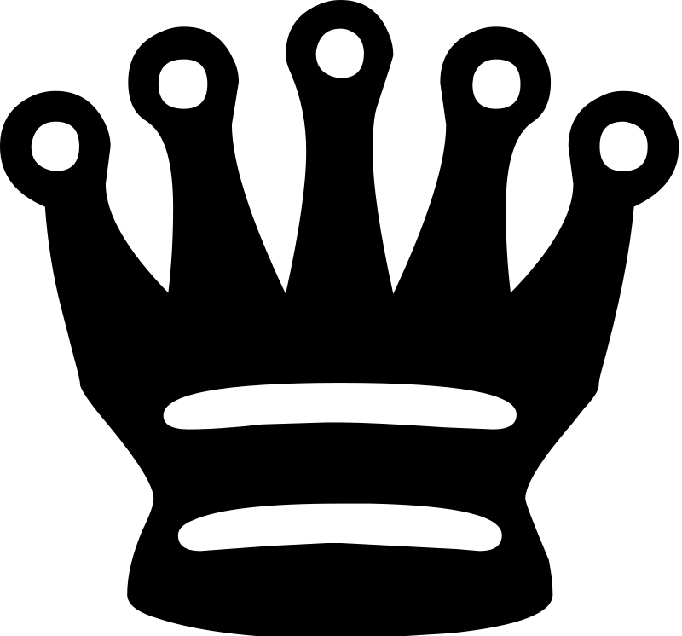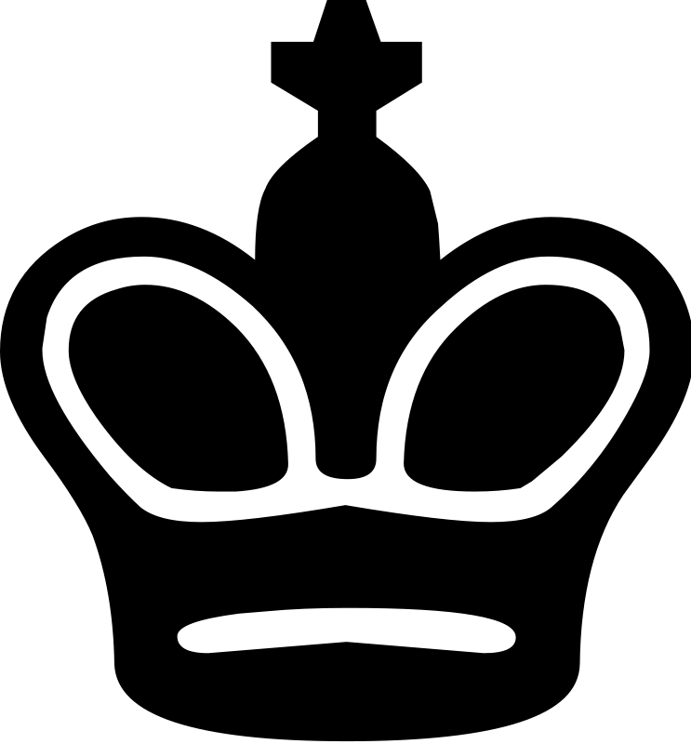

Your Job:
Create a chess set that shows your understanding of the content that we have been studying in class. Create two models of each of the six different characters that are found in a chess set: pawn, king, queen, knight, bishop and rook. You will be designing both sides of the chessboard. The design of each chess piece should show your understanding of the game of chess and of the content that we have been studying in class. You will make 12 pieces, 6 pieces from each side.

Resources
You can find detailed information, pictures and explanations about the jobs and the importance of each chess piece on the websites below:

The Rules of Chess  Chess Pieces and Their Meanings  The Values of Each Chess Piece | Beginner’s Guide to Chess Pieces  Chess Pieces from Wikipedia

Planner
Remember that these two sides are opposing or opposite each other.
Piece | What is this piece’s job in chess? What kind of moves can they make? What is their role in the game? | Side 1  What symbols, characters, motifs, objects or ideas can “play” this role? Why? | Side 2  What symbols, characters, motifs, objects or ideas can “play” this role? Why?
Pawn
King
Queen
Knight
Bishop
Rook

Tinkercad.com Chess Set Examples

People’s Chess Set by Joshua Adam Turner

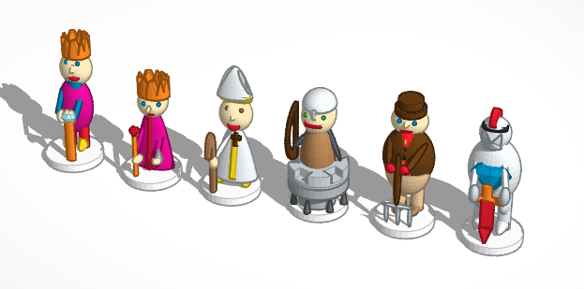

Spooky Chess Set by MakeALot

